Practical 10: Hash Tables: Linear Probing, Chaining, and
Double Hashing
Practical Aim
To implement hash tables using different collision handling strategies and develop the ability to
reason about why collisions occur, how different strategies resolve them, and what trade-offs
each approach involves.

Problem 1:
A small parking lot has exactly 10 numbered slots (0 to 9). When a vehicle arrives, its
registration number is used to assign it a slot by taking the last digit of the number. If that slot is
already taken, the vehicle moves to the next available slot in order, wrapping around if
necessary. Given a sequence of vehicle registrations, assign each to a slot using this rule and
display the final state of all ten slots.
Describe what your solution does when it encounters an already occupied slot. What happens
when the parking lot is nearly full and many vehicles keep landing on the same slot? Can you
think of a situation where your solution might loop indefinitely?

For code :

https://github.com/kvvaghasiya49/FDSA/tree/6fb2f463bf1f58ac 408ada5ca8ffdaa64bc82087/DSA

Output:
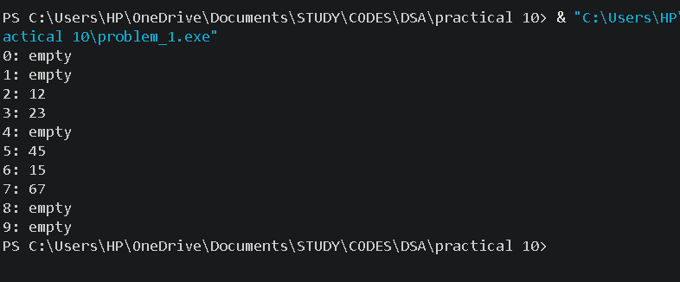

Problem 2
A library uses a system with 10 shelves numbered 0 to 9. Each book's code is used to decide
which shelf it belongs to by taking the code modulo 10. Unlike the parking lot, each shelf can
hold multiple books stacked together — when two books map to the same shelf, they are simply
added to that shelf's stack. Given a sequence of book codes, place each on the correct shelf
and display the final contents of all shelves.
Describe how your solution handles two books that map to the same shelf. What happens to
search time on a shelf as more and more books pile onto it? Can you think of what would cause
all books to end up on the same shelf?

For code :

https://github.com/kvvaghasiya49/FDSA/tree/6fb2f463bf1f58ac 408ada5ca8ffdaa64bc82087/DSA

Output:

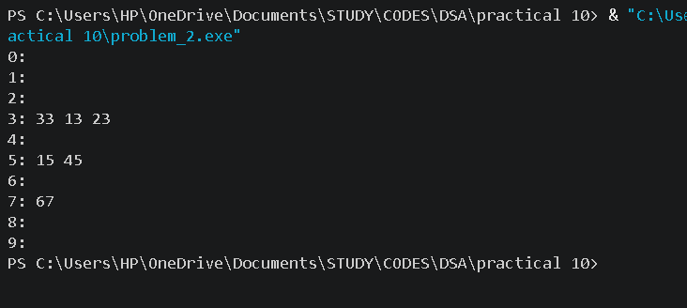
Problem 3
A university assigns student IDs to storage slots using a two-step rule. The first rule determines
the initial slot. If that slot is taken, instead of simply moving one slot forward, a second rule
based on the ID itself determines how many slots to jump. This means different IDs that collide
will probe different sequences of slots, spreading them more evenly. Given a sequence of
student IDs, assign each to a slot using both rules and display the final state of the table.
Describe how your solution decides how many slots to jump when a collision occurs. What is
the risk if the jump size happens to be a factor of the table size? How does this strategy differ
from Problem 10.1 in how it spreads collisions?

For code :

https://github.com/kvvaghasiya49/FDSA/tree/6fb2f463bf1f58ac 408ada5ca8ffdaa64bc82087/DSA

Output :

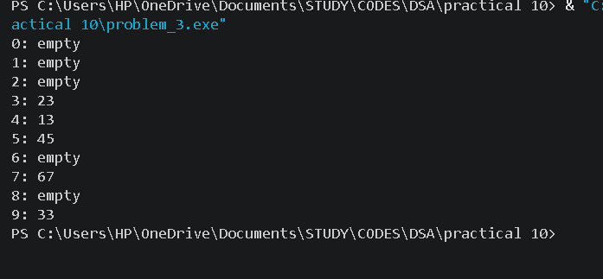
Challenges Faced:
In linear probing, the difficult part was the wrap-around. When the slot was occupied, I moved to the next slot, and after slot 9 I had to go back to slot 0 using modulo. At first my program went outside the array. I also had to count the filled slots, because when the table is full the loop keeps searching for an empty slot and never ends, so I added a check before inserting

Learning Outcomes:
I learned how a hash function (like the last digit or modulo 10) decides the slot for a value, and why collisions happen when two values get the same slot.
I learned how linear probing, chaining and double hashing each resolve a collision in a different way.
I understood that linear probing creates clusters of filled slots, and that chaining keeps all colliding values on one shelf but makes searching slower as the shelf grows.

Key Questions / Analysis / Interpretation to be Evaluated During/After
Implementation:
1. [Problem 1] If five consecutive vehicle registrations all end in the same digit, trace where each one gets placed in the parking lot. Now explain why this clustering effect is a structural weakness of this collision strategy — not just for this input, but in general.
Ans :
Suppose all five registrations end in 3. The first goes to slot 3. The second finds slot 3 full and goes to slot 4. The third goes to slot 5, the fourth to slot 6 and the fifth to slot 7. So they form one continuous block from slot 3 to slot 7. This is a structural weakness because linear probing always moves to the next slot.
2. [Problem 2] Suppose all book codes in Problem 2 are multiples of 10. Without tracing through the code, predict what the final shelf layout would look like and explain why. What does this tell you about the relationship between the hash function and the input data?
Ans :
Every multiple of 10 gives 0 when divided by 10, so code % 10 is always 0. All the books would be placed on shelf 0, and shelves 1 to 9 would stay empty. Shelf 0 would become one long chain, and searching it would be as slow as searching a simple list.

3. [Problem 3] In Problem 3, what would happen if the second rule always produced a jump size of zero? Trace through the consequence and explain how this failure is related to the choice of the second hash function rather than the data itself.
Ans :
If the jump size is always zero, then when the first slot is already taken, the next slot to check is the first slot plus 0, which is the same slot. The program checks the same occupied slot again and again, so the insertion goes into an infinite loop and the student ID is never placed.

